**USER’S**

**Guide**

*Smart Bin Application*

Techngage Competition

April, 2016

**Revision Sheet**

|  |  |  |
| --- | --- | --- |
| **Release No.** | **Date** | **Revision Description** |
| Rev. 0 | 27/04/2016 | User’s Guide Template |
|  |  |  |
|  |  |  |
|  |  |  |
|  |  |  |
|  |  |  |
|  |  |  |

**USER'S MANUAL**

**TABLE OF CONTENTS**

1.0 INTRODUCTION 4

1.1 Purpose 4

1.2 Scope 4

2.0 APPLICATION SUMMARY 5

2.1 Key Features 5

2.2 Software Architecture 6

3.0 INSTALLATION 7

3.1 Software Requirements 7

3.2 Installation of MongoDB 7

3.3 Installation of Maven 8

3.4 Installation of JDK 1.7 8

4.0 DEPLOYMENT 9

4.1 Deployment on Windows 9

5.0 GETTING STARTED 10

5.1 Logging On 10

5.2 Viewing Route 11

5.3 Assign Route 11

5.4 Un-Assign Route 11

5.5 Viewing Route History 11

5.6 Viewing Route Escalated 11

5.7 Viewing Route Assigned 11

5.8 Viewing Route Progress Details 11

5.9 Logging Out 11

**1.0 INTRODUCTION**

**1.1 Purpose**

**1.2 Scope**

**2.0 APPLICATION SUMMARY**

**2.1 Key Features**

**2.2 Software Architecture**

**3.0 INSTALLATION**

**3.1 Software Requirements**

We have currently deployed our SmartBin application successfully on Windows 64-bit machine which needs the software components as MongoDB 3.2, Maven 3.x and JDK 1.7

**3.2 Installation of MongoDB**

1. Unzip the prototype zip and look for mongod batch file located at \SmartBin\mongod
2. Run this mongod by double clicking on it.
3. Now, check for mongod installed at path “C:\Program Files\MongoDB”
4. Add path till bin folder i.e. “C:\Program Files\MongoDB\Server\3.2\bin” to Path in System Properties as shown in the screenshot below.
5. In order to start and run MongoDB server

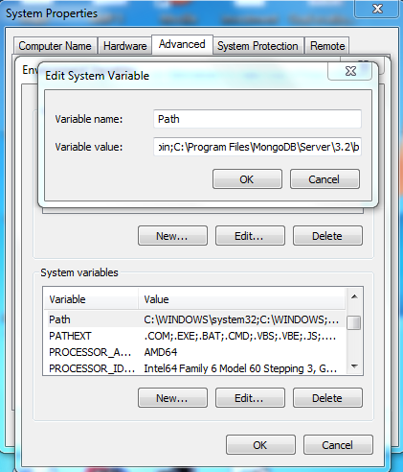

1. Before you run mongod in command prompt, please ensure you have created data folder in the same path from where you are executing this command. For e.g. “C:\data”
2. Now open a command prompt and run mongod. You will see waiting for connections on port 27017 upon successful execution of this command as shown below.

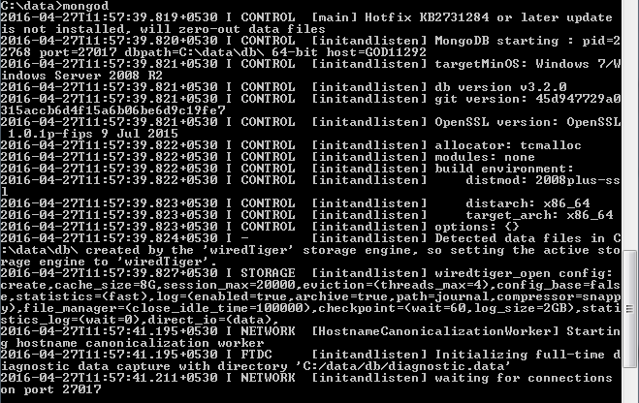

**3.3 Installation of Maven**

1. Use the apache-maven-3.2.5 provided in the prototype or you can download maven project (preferably above 3.x) from the maven apache org. Please find the download link here <http://maven.apache.org/download.cgi#Installation>
2. Go to path in prototype “\SmartBin\apache-maven-3.2.5\bin”
3. Now, add “D:\SmartBin\apache-maven-3.2.5\bin” to Path in System Properties as how it was done above for MongodDB.

**3.4 Installation of JDK 1.7**

1. Download JDK 1.7 from Oracle.com for windows. Please find the download link below. <http://www.oracle.com/technetwork/java/javase/downloads/jdk7-downloads-1880260.html>
2. Run the installer downloaded.
3. After the installation is complete, you will see it is being installed at “C:\Program Files\Java”
4. Add “C:\Program Files\Java\jdk1.7.0_45\bin” to Path in System Properties similarly as how it was done for MongoDB and Maven.

**4.0 DEPLOYMENT**

**4.1 Deployment on Windows**

1. Ensure that all the mandatory software components like JDK 1.7, Maven 3.x and MongoDB 3.2 are installed and configured successfully on windows machine.
2. Unzip the smartbin.zip on any drive for e.g. D:\SmartBin\SmartBin
3. Go to the “D:\SmartBin\SmartBin” where pom.xml file exists.
4. Open a command prompt at “D:\SmartBin” and run the mvn clean install command as shown below. This will take some time to download all the required dependencies. Once completed successfully you will see a message in command prompts as BUILD SUCCESS.

D:\ SmartBin\SmartBin>mvn clean install

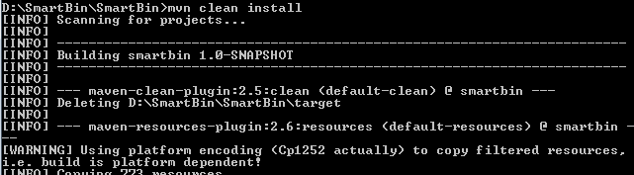

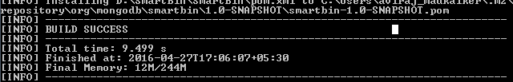

1. Run the main Controller class of smartbin Application by executing the following command. Please check the screenshot. Upon successful execution of this command, you will see the message in command prompt as == Spark has ignited ... >> Listening on 0.0.0.0:8082

D:\SmartBin\SmartBin >mvn exec:java -Dexec.mainClass=com.techngage.smartbin.Controller

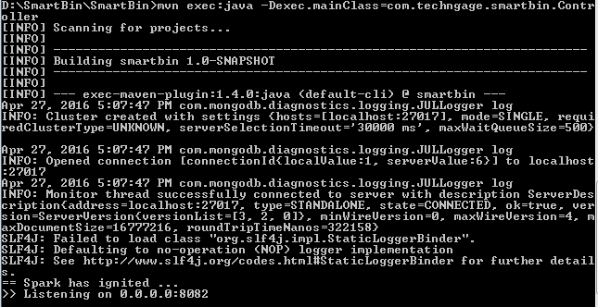

1. Now the SmartBin application is deployed successfully and is available on <http://localhost:8082/welcome>
2. Go to Crome or IE browser and type <http://localhost:8082/welcome>
3. You will be asked to Login with User-Name and Password. (**Note:** Password is hashed with MD5 encryption)
4. Enter User-Name as Aviraj and Password as 123 and click on Login button.
5. Upon clicked on Login, you will be navigated to welcome page.

**5.0 GETTING STARTED**

**5.1 Logging On**

**5.2 Viewing Route**

**5.3 Assign Route**

**5.4 Un-Assign Route**

**5.5 Viewing Route History**

**5.6 Viewing Route Escalated**

**5.7 Viewing Route Assigned**

**5.8 Viewing Route Progress Details**

**5.9 Logging Oout**